**EXPERIMENT-2**

**DESIGN AN LED CHASER**

**Circuit diagram:**

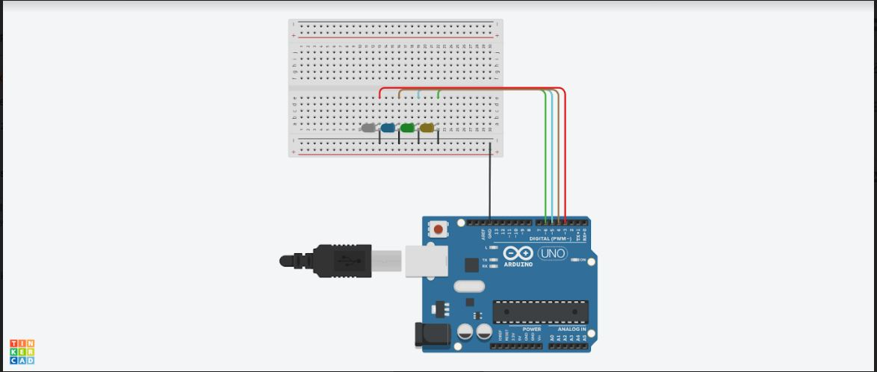

|  |
| --- |
| Take 1 breadboard, 5 LED S, 1 Arduino board and 11 wires. Install 5 led S in breadboard in such a way that their terminals are connected and terminals should not be connected. By taking 5 wires connect all terminals and from there take another wire and connect it to the ground of digital pins in arduino board . Now take another 5 wires and connect to terminals of led S such that every terminal contain 1 wire. Now take all the 5 wires of terminal and connect any 5 pins of arduino board. By using cable connect the arduino board to the computer. |
|  |

**THEORY:**

**Concepts used:** 1. Ohms law

2. Circuit completion

3. Arduino ide

4. Use of breadboard

**Learning and Observations:**

1. Need of resistance

2. Led forward biasing

3. Appropriate value of resistance

4. Error free adruino code

5. proper connection of wires

**Problems and Troubleshooting:**

|  |
| --- |
|  |
| You should take care whether the board in the Arduino\UNO or not and also selection of port in tools. |
|  |

**Precautions**

|  |
| --- |
| While installing LED in bread board we should take care whether the terminals of LED connected or not. The two terminals should not be connected. Wires should be properly installed. Make sure resistance is connected. Arduino isn’t corrupt. |
|  |  |

**Learning Outcomes:**

|  |
| --- |
| With this experiment we can learn that how leds are blinking in such a way that 1,2 & 2,3 & 3,4 & 4,5 & 5,1.These are all the positions at which led blinks. This is the step by step process. |
|  | } |